Monitoring and reporting on government policies

A toolkit for civil society organizations

___________________________________________________________________________________________________

This publication has been produced with the assistance of the European Union. The contents of this publication are the sole responsibility of Project and can in no way be taken to reflect the views of the European Union
Table of Contents
Table of Contents 2
Introduction 4
Chapter 1- Policy and policy monitoring 5
1.1 What are the core concepts in policy monitoring? 5
1.2. Beginning to develop a monitoring approach 10
Chapter 2- Choosing policies 13
2.1 What are the different kinds of policies? 13
2.2 Choosing Policies - practical tips 15
Chapter 3- Stakeholder Analysis 16
3.1. Stakeholders inside public institutions 16
3.2. Stakeholders outside public institutions 17
3.3 Target audiences and partners 17
3.5 Monitoring by a network of stakeholders 19
Chapter 4- Defining monitoring objectives and gathering evidence 22
4.1 Defining your monitoring objectives 22
4.2. Gathering evidence 23
4.3. Ways of gathering evidence 24
4.4 Interviews 24
4.5. Surveys 28
4.6. Analyzing data and other coded information 28
4.6. Workshops, focus group discussions and observation 32
Chapter 5- Using Policy Evidence to advocate for change 36
5.1 Planning for advocacy 38

Introduction

Community Building Mitrovica (CBM) is a nongovernmental organisation committed to strengthen the capacities of the monitoring team on principles and standards of monitoring the performance of local self governments as well as advocacy and lobbying techniques.
Civil Society is watching you: demand for accountability and transparency on local level is a project implemented by CBM and CRYM. The project is supported by the European Union Office in Kosovo and co-financing by the Austria Development Agency, Royal Embassy of Netherlands and Mott foundation.
The overall objective of this project is to contribute in increasing the accountability and transparency of local institutions through active participation of civil society, and it is set to be implemented in two years in Mitrovica and other municipalities: Mitrovica North and South, Vushtrri/Vucitrn,Serbica/Skenderaj, Zveçan/Zvečan, Leposaviq/Leposavić and Zubin Potok/Zubin Potok.
Throughout the project, implementing organizations have several goals to achieve:
- to Increase capacity of local CSOs on lobbying, advocacy and monitoring local institutions;
- to established body for monitoring local authorities - Mitrovica Region Monitoring Team (MRMT);
- to raise awareness of citizens for social accountability through monitoring
In order to support development of the CBM staff but also the monitoring staff of other organizations, CBM commissioned preparation of this toolkit which attempts to provide an overview of the standards and principles for effective policy monitoring work.

This toolkit is not a textbook or instruction manual. The main purpose of this document is to provide advice and guidance for civil society organizations working in the area of monitoring public authorities and contributing to increase of transparency, good governance and civic participation. Definitions, key principles, methodologies accompanied with practical examples and tips make this document a toolkit for use of civil society organizations.

Another purpose of this toolkit is to provide an introduction to policy monitoring as a way of making a difference in our societies. The aims of this resource document are to:
- give you a clear overview of what policy monitoring is;
- introduce you to key terms and methods that are used in policy monitoring;
- provide ideas on how your organisation or network could plan activities to monitor policies.

Who will find this resource useful?

An organisation in its simplest term can be defined as people and/or groups that seek to achieve one or more common objectives, according to generally agreed rules and procedures. An organisation does not have to be formal, with written constitutions, objectives and procedures, as long as there is a common understanding among its members about the objectives and the way to achieve them. Larger organisations, however, over time have establish more formalized way of operating as they grow in terms of staff, budgets and number of locations where they operate.

This toolkit is prepared based on the several reports, textbooks and manuals prepared by various authors, institutions, and organizations. It is dedicated to civil society organisations (CSOs) in Kosovo and more specifically in Mitrovica region and is prepared with the following target audience in mind: organizations with solid experience in monitoring government policies; CSOs with a specific interest in strengthening accountability at any level of government; CSOs that have a strong social base and the capacity to build, coordinate or participate in networks. facilitators, planners, catalysts or trainers within their own organisations or networks.

Chapter 1- Policy and policy monitoring

This chapter aims to clarify the core concepts and help you start to plan your own policy monitoring work. It explores the following questions: what is policy and policy monitoring, what problem or situation do you want to change, which approach to policy monitoring to adopt?

This chapter introduces the following tools: TOOL 1: Problem Tree and TOOL 2: Solution Tree

1.1 What are the core concepts in policy monitoring?

What is policy?
There are many different kinds of policies. This toolkit is mainly focused on government policies, also called public policies. In this context, policy is understood as a course of action, authorized by government, to achieve certain goals. Such a course of action may take many forms. It could, for example, take the form of a law, a strategy or a programme. Even a speech made by a president or a minister could outline a government’s planned course of action.

Public policies are not created in a vacuum. Many people affected by these policies have an interest in determining the content of that policy. Policies can also be seen as processes: they change as they are implemented and rarely conform to plan. Policies can have intended and unintended outcomes.

What is policy monitoring?
Policy monitoring is about gathering evidence on a policy while it is being implemented and then using your findings to influence future courses of action. This toolkit explores three main components of policy monitoring work:

- gathering evidence
- analyzing evidence
- influencing policy decisions.

What are stakeholders?
Stakeholders are all the people who have an interest in a particular policy, including people who can and do influence the policy, as well as those affected by it.

Why there is no single model for policy monitoring
Every organisation faces the challenge of developing an approach that suits both its situation and goals. The following factors play an important role in defining which approach an organisation decides to adopt:

Time frames: Some organisations monitor policies on a continuous basis as part of their core function. For example, a health-policy-watch network would probably monitor health policies in an ongoing way. On the other hand, many monitoring projects have specific time frames. You could decide, for example, to monitor the implementation of a specific policy over a twelve-month period. Or you could choose to monitor a policy area periodically, say every two or three years, to gather evidence on longer-term trends.

Level or area of government: Many organisations monitor government policies at the national level: they identify and track policies that are national in scope and gather evidence to present nationwide findings. By contrast, some very successful monitoring projects focus on the sub-national or local level. The more decentralization there is, the more likely you are to focus on policies at the sub-national and local level.

Policy focus: Monitoring projects differ vastly in terms of the issues and policy areas they focus on. Some organisations monitor specific sectors, like education, health, housing or welfare. Others might monitor how a certain policy – for example a trade policy – impacts across various sectors. There is really no prescription when it comes to selecting a focus for your monitoring work, although it may be advisable to start out with a single policy area, rather than taking on too many policies at once.

What is the policy cycle?
In theory, government policies are supposed to follow a cycle – similar to the one shown in the chart below. But in reality, policies rarely follow this pattern.

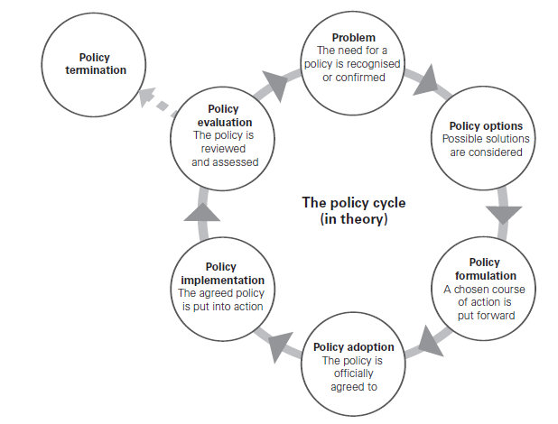

What is the difference between monitoring and evaluation?
The terms ‘monitoring’ and ‘evaluation’ are often used together. Monitoring is an ongoing activity that takes place during policy implementation. The aim is to track (and adjust) the process as it is on-going. Evaluation, on the other hand, is conducted at the end of an implementation period. The aim of evaluation is usually to help decision-makers to assess the overall impact that a policy has made.

Political interests often influence how a policy gets implemented in practice. For example, if the political leadership of a country changes after an election, policies may be changed or replaced without completing the cycle.

When CSOs participate in policy formulation, they are working primarily in one part of the policy cycle. Likewise, when they help to implement services, they are busy in another part of the policy cycle. Policy monitoring is really about taking account of the entire policy cycle, especially of what happens inside the arrows on the chart above. Many policy-monitoring initiatives give special attention to the left hand side of the chart. In other words, they track what happens once a policy has been adopted to see how it is implemented and what it achieves.

No single model for policy implementation?
Policy implementation is the process whereby a written policy is turned into actions that makes a (positive or negative) difference to peoples’ lives. This process involves a chain of causes and effects (called a causal chain). This chain is often complex as many different things can influence the effects a policy can have. The chain will be different for every policy in every context.

The policy implementation process
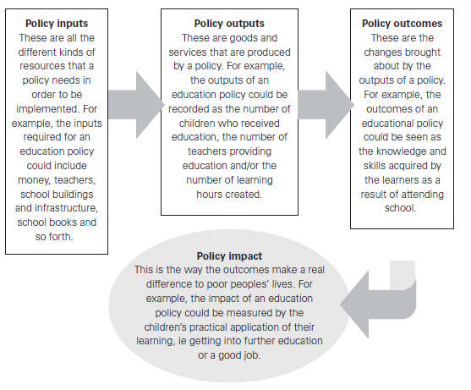
TOOL 1: Problem Tree
Aim: To gain a deeper understanding of a problem or situation by identifying its causes and effects. This tool works well with a team/group, and it is a useful way to capture the ideas generated through discussion. It is especially helpful to identify some of the longer-term causes of a problem.

How to use this tool
Step 1: Draw a tree trunk on a large sheet of flip-chart paper. The trunk represents the problem or situation you are researching /investigating.
Step 2: Add roots. They represent the causes of the problem or situation. Some roots are closer to the surface: these are the more obvious factors that contribute to the problem. But what causes these factors? The deeper you go, the more causes you uncover that help to contribute to the problem or situation.
Step 3: Draw the branches. They represent the effects of the problem. Some branches grow directly from the trunk: these are the problem’s more immediate effects. But each branch may sprout many more branches, showing how the problem may contribute to a range of indirect and longer-term effects.

Example: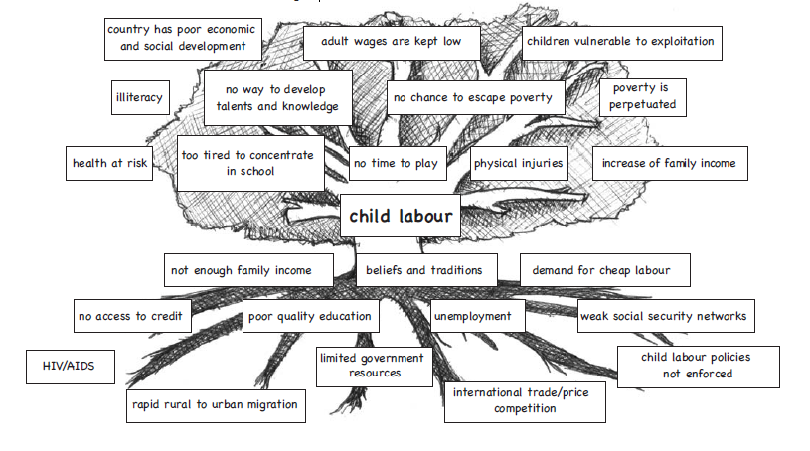
TOOL 2: Solution Tree

Aim: To identify possible short- and long-term solutions to a problem. This tool can be used individually or for brainstorming with a group. You will need to have a problem tree (TOOL 1).

How to use this tool
Step 1: Draw a tree trunk on a large sheet of flip-chart paper. The trunk represents what you would like a certain situation to be like in the future.
Step 2: Add roots. They represent possible solutions or methods to bring about the desired future situation. The solutions should relate to the main causes of the problem as indicated in the roots of your problem tree. The roots that are closer to the surface are those that would contribute most directly to improving the situation. The solutions may also reinforce each other.
Step 3: Draw the branches. These represent the effects of the improved situation. Some branches grow directly from the trunk: these are the more immediate effects. The longer branches are used to represent the longer-term effects of the improved situation.

Example:
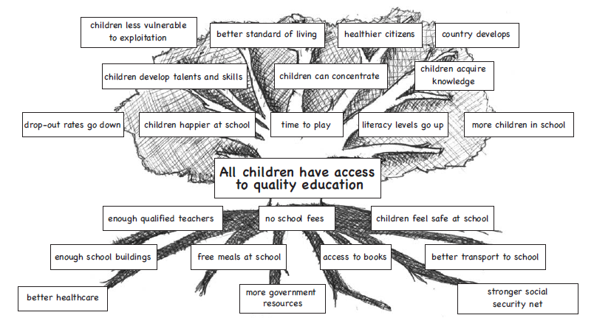
1.2. Beginning to develop a monitoring approach

This section aims to assist you to begin planning your approach to policy monitoring by thinking about three important questions:

- From what perspective will you monitor policies?
- What level of participation will you build into your work?
- What does adopting a team approach to policy monitoring mean?

Monitoring perspectives
Government policies cannot be monitored from a neutral position. All policy monitoring is done by a certain perspective. Organisations are motivated by different principles, beliefs and priorities. It may be a commitment to human rights, compassion for the poor, dedication to non-violence, the desire to strengthen democracy etc. In planning your approach to policy monitoring, a good starting point is to be explicit about your guiding principles and perspective. This will help you to define the broad aim of your policy monitoring.

Here are a few examples:
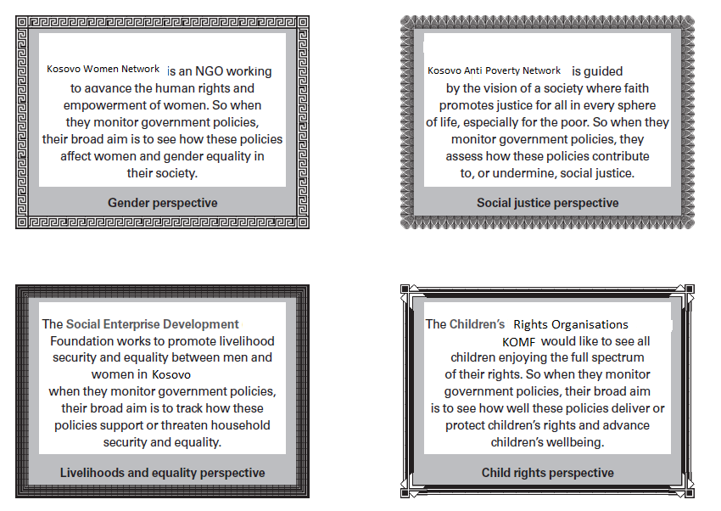

Working in a participatory way

There are no rules about who should be involved in monitoring policies. The work could be undertaken as a small project team, as an organization or a network. However, experience shows that the more participation you can build into the process, the more effective your policy monitoring work will be in the long-term. Who participates – and how – can vary greatly. In fact, many kinds of processes are described as ‘participatory’ even though they may range anywhere between the following poles:
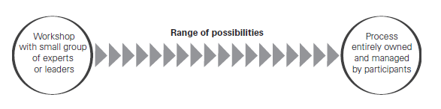
Depending on the quality of participation, this approach can add depth and insight to all policy-related work. However, it is important to take the following into account:

Challenges of participatory approaches | Conditions for effective participation
- Representation is often a problem: there is a need to guard against the assumption that participants can speak on behalf of others.  - Ideas generated through participation are not always or inevitably reliable or effective.  - Power relations among participants affect what is said about what and to whom.  - Be aware of exploitation: participation processes can be resource- and time-consuming for poor people without providing benefits or decision-making power in exchange.  - One-off participation events can’t take the place of in-depth research and analysis.  - The rhetoric of participation can be misused to mask processes that are superficial, unequal or geared to further vested interests. | - The right voices must be present: this requires careful thinking about the stakeholders you intend to engage with (see chapter 3) and explicit planning to ensure that the process does not exclude any of them.  - The process must ensure that those voices can speak, it should be designed in such a way that all participants feel able and willing to contribute.  - Those voices must be heard – by each other and documented for others. This involves finding effective means to facilitate dialogue among stakeholders and reporting on the ideas that emerge.  - Those voices must be listened; the process should ensure that the views of participants are made known to policy-makers and other powerful stakeholders.

A team approach to monitoring

Various policy stakeholders could be involved in monitoring its implementation. It is useful to consider what it means to develop a team approach to policy monitoring. Policy monitoring can be undertaken by a single CSO. It is not impossible for a large organisation, with diverse skills and a broad membership base, to undertake policy monitoring on its own. Yet in most cases, there is a need for various organisations and individuals to collaborate when monitoring a policy because:

- Some organizations/individuals have skills or contacts and play a crucial role in gathering evidence;
- Others may have experience in analyzing different kinds of information;
- Some may have greater capacity to advocate to different audiences;
- Some organisations can contribute in more than one way by working at different levels.

Chapter 2- Choosing policies
This chapter is focused on assisting the CSOs to identify which policy or policies they could monitor. It explores different kinds of policies and the ways they can affect people. It also looks at the various policy documents that may be useful to CSOs and the challenges of collecting information about a policy. It explores the following questions:

- What different kinds of policies exist?
- How do these policies affect people’s life?
- Which policies impact on the problem or situation you are trying to address?
- What factors should you consider when choosing policies to monitor?

2.1 What are the different kinds of policies?
Governments have many policies in place. Every country has its own mix of policies, shaped by its history and directed by its current government. Every policy you monitor, therefore, co-exists with, and is influenced by, a whole range of other policies. In most developing countries, governments use policies to pursue all, or at least most of the following functions:
Governments use policies to:

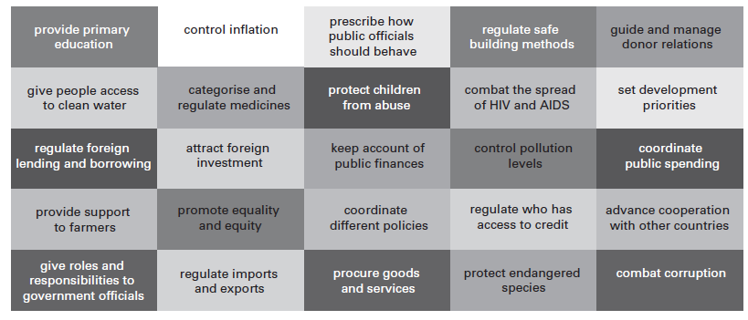

If your organisation or network is involved in policy monitoring, it is important to build awareness of the current policies in your country, and to understand how they are related. This will help you make a decision about which policies are most relevant and crucial to monitor.

What if there is no policy?
There may not be any government policies related to the area you want to monitor. For example, there may not be a policy on corruption, disability or social security. What do you do if there are no policies related to your issue? Or what if existing policies are old and outdated? You may first need to advocate for a new policy, or for existing policies to be updated.

EXAMPLE: Country policies that may impact on poverty

Sectoral policies
Most countries have numerous policies that guide or regulate the delivery of services such as health, education, water, finance, housing, policing, welfare, justice, agriculture and so forth. These are often called sectoral policies. It is through sectoral policies that most goods and services are delivered (or not delivered) to people. For example, there are clear implications for people living in poverty when an important health policy is not implemented well.

Macro-economic policies
Governments use a variety of policies to influence economic activities in their country. Such policies are used, for example, to regulate government income and expenditure, to promote economic growth and to stimulate job creation. Governments do not have total control over the macro-economic environment. What happens on a global level has an important influence. Yet macroeconomic policies influence how much money will be available for spending on goods and services to reduce poverty. It also affects how many people will be able to earn a fair income. So from a poverty perspective, macro-economic policies are an important focus for monitoring.

Institutional policies
Governments create policies to guide and manage their own institutions, employees and work processes. For example, most countries have policies on how public funds should be managed and on how civil society can participate in decision making. These kinds of policies have an important influence on effective implementation of other policies. Institutional policies can be key targets for monitoring. For example, it may be useful to track the public finance management or staff performance of a government.

Regulatory policies
Regulatory policies are used to impose norms and standards across a wide range of areas, such as pollution levels, food safety, medicines, endangered species and construction. Formal monitoring bodies are often created to ensure these kinds of policies are adhered to. Yet, there may cases when CSOs want to include regulatory policies in their monitoring. For example, if water pipes in a poor urban area always seem to leak, it may be useful to look at the regulations guiding water provision and collect evidence on their infringement.

National development plans
Many governments already have policies to guide their overall strategy for development. Such policies may be called a poverty reduction strategy paper (PRSP) or other names: development plans, national strategies, anti-poverty policies or five-year plans. These kinds of policies generally state how government plans will be implemented in a given time. They usually combine elements of sectoral, institutional and macro-economic policies, often held together by a set of guiding principles or policy goals. By their nature, these kinds of policies call for high levels of coordination and collaboration across government.

Global and regional policies

International and regional standards, such as human rights treaties and trade agreements influence policies adopted and implemented by governments. In some instances, it may be useful to monitor discrepancies or conflicts between national and international policies, and how this undermines progress in combating poverty. For developing countries, the policies of donor organisations and international financial institutions (IFIs), such as the World Bank or IMF, also play a powerful and controversial role.

2.2 Choosing Policies - practical tips

Points to keep in mind when analyzing policies in your own context

- Policies can be in various stages of development. Most often, a policy initially appears in the form of a draft proposal or discussion paper and usually gets revised before being adopted or rejected.
- Specific attention should be paid to draft policies as there may be policies you want to influence before they are adopted. Once adopted, policies differ in legal status. Some policies become laws and some take the form of policy statements, strategies or plans of action, adopted officially by the government.
- When identifying policies to monitor, it is important to consider their legal status. This will determine what sanctions can be applied if a policy is not implemented.

Issues to consider when choosing policies to monitor

- Some policies have direct and intentional affect on peoples’ lives while others have a more indirect and unintentional consequences.
- Policies also differ in terms of timeframe they begin to make difference. Some policies have immediate effects, for example a policy providing clean drinking water to rural communities. On the other hand, an education policy that provides greater emphasis on science and mathematics can only be expected to produce benefits over the longer term.
- Policies may cover national, regional or local levels. It is important to consider geographical scope of implementation when making your choice.
- Some policies have more positive impact on the poor than others. They may be implemented too slowly or inefficiently, but have the potential to do well. On the other hand, there are policies that, by their very nature, produce negative outcomes for the poor, such as introducing or increasing fees for public services like education and water. Choosing to monitor such policies can reveal their adverse effects and bring them under closer public scrutiny.

Chapter 3- Stakeholder Analysis

This chapter of the toolkit aims to analyze the stakeholders that shape government policies, implement them and influence their future direction. In specific addresses the role of the government, which has the formal mandate to make, implement and enforce policies, all the individuals, organisations and agencies that play a role in designing, implementing and evaluating the policy, and all the people who experience benefits or harm as a result of a policy being in place.

3.1. Stakeholders inside public institutions

Parliamentary committees
Members of parliament generally don’t have time to analyze implications of every single policy in a country. This work is done through parliamentary committees. Without a strong committee system, it is impossible for parliament to be effective and informed in holding the executive to account.
Parliamentary committees in many developing countries are under-resourced and often have few resources available for research and monitoring. Parliament committees have a keen interest in the evidence from your monitoring work. Such evidence can assist them to perform their own function of providing parliament with reliable and sound information on the outcome and impact of policies.

Stakeholders within government
In the case of most policies, we cannot consider the government as a single stakeholder. Different government entities get involved with policies at different levels, in different ways and at different stages. There are often tensions within government departments or ministries, as well as diverse interests and agendas. This affects the way policies are designed and implemented.
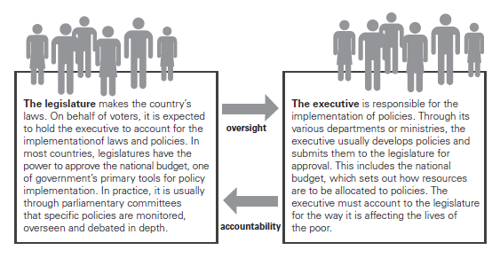

There are also other institutions with an interest in policy implementation, for example:
- The auditor-general, in most countries, must ensure that public funds are being managed and accounted for in an honest and transparent way;
- A national statistics office responsible for recording, analyzing and providing data to support policy planning and implementation;
- Commissions and boards that have the responsibility to oversee particular cross- cutting issues (such as human rights) or provide support to specific sectors (such as energy or agriculture).

3.2. Stakeholders outside public institutions
Below is a list of the main stakeholders outside the government:

- The final beneficiaries or intended beneficiaries of policies clearly have an interest in the effective implementation of a policy;
- Those excluded from or harmed by policy implementation can also be seen as stakeholders, as they could benefit from a review and change in policy;
- The public are stakeholders of policy implementation in the sense that they have the right to know how the government is using their country’s resources to improve people’s livelihoods.
- Civil society organisations may be stakeholders of a policy. As citizens they have the right to monitor their government’s policies. They may have been involved in the formulation, implementation and/or monitoring and evaluation of certain policies. International CSOs may also have a keen interest in policies that fall within their focal areas.
- The media is an extremely important category of stakeholders to consider. Journalists can play a critical role in drawing attention to and disseminating information about policy issues.
- The private sector may have a stake in policy implementation, especially if the policy has (or intends to have) an effect on employment, economic stability and skills development.
- Donors and IFIs are powerful policy stakeholders. Their influence may be more overt in the policy development process and less direct during policy implementation.

3.3 Target audiences and partners

Target audiences
When you gather evidence about a policy, it is important to think and remember to whom you will present the evidence and why. The evidence should influence specific people: especially those who have the power to change a policy or improve the way a policy is being implemented. They represent the primary target audience that you want to influence when monitoring relevant policies.

This includes individuals that have direct decision-making power over the content and implementation of policies. It also includes those who have more indirect influence, such as: advisors who inform the decision makers; people who have influence behind the scenes; those who exert pressure on decision makers, including the people who are affected by policies.

Potential partners
In order to ensure a smooth monitoring process it is necessary to clarify the nature of the relationships you enter into with different partner organisations and where appropriate, formalize them. Different forms of cooperation may be suitable for different stakeholders such as formal partnerships or network agreements; informal partnership or periodic/task-specific cooperation; or informal and unofficial understanding of mutual goodwill/willingness to exchange information.

Kinds of stakeholders
In every context, every policy has its own unique combination of stakeholders. However below are listed some of the kinds of stakeholders to think about:

- Vulnerable stakeholders are those who are most deeply affected by the successes and failures of a policy, or by being excluded from policy benefits.
- Powerful stakeholders are those who have influence over policy implementation and are affected by its outcomes. Some may have an interest in seeing a policy succeed, while others may have reasons to obstruct or undermine it.
- Implementing stakeholders are those who play a critical role in the implementation of policies. Their power is usually in the everyday routine of undertaking decisions and actions.
- Knowledgeable stakeholders are those who may influence the policy process by providing (or withholding) information and expertise. They may belong to any of the stakeholder categories or they may be independent researchers or experts.
- Other affected stakeholders are those who are likely to be directly or indirectly affected by the policy, but who are neither very vulnerable nor powerful.

3.5 Monitoring by a network of stakeholders

Monitoring process of a policy and reporting can be done by a single organisation and in a team of partnership of two and more organizations. Depending from the context and nature of the monitoring task the approach can be adjusted to combine the expertise and achieve desired results. Most frequently used approaches that organsiations apply when doing a team monitoring process, are the sector-based network and a monitoring chain.

Sector-based network
The structure that works best to support a monitoring network depends on the nature of the organisations involved, their relative capacity and the policies chosen to be monitored. The star network works well when a range of organisations specialized in different sectors get together to monitor a group of policies and generate a shared advocacy message. For example, three or four organisations might cooperate to monitor different policies that all have a focus on women’s safety.

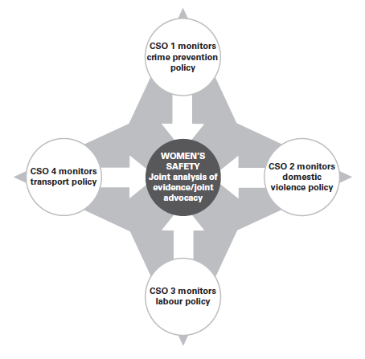
Monitoring chains
Another option of a team monitoring task is to match up organisations that can monitor a policy at different levels of government, thereby enhancing their monitoring efforts.

For example, there are a number of CSOs able to monitor the implementation of a new education policy at the local level. Yet none of them, on their own, is able to gather evidence on a larger scale, or draw conclusions about the broader effects of the policy. Within a monitoring chain, each local organisation passes on the evidence it gathers to the next regional (sub national) level of the monitoring project and further to a national network or coordinating body. In this way, individual organizations are able to catalyze their strengths and build a collective body of evidence. This evidence can be used for advocacy at the local, regional, national and even international level.
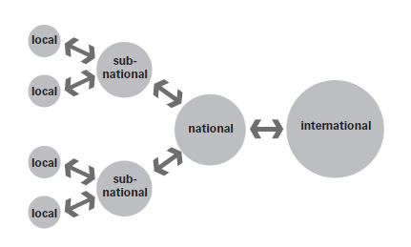

Building a network of organisations to advance your monitoring objectives can be a challenging task. It means creating and maintaining relationships of trust between multiple players who often have diverse needs, capacities and interests. It also calls for strong management skills to coordinate activities, facilitate joint ownership and decision making, manage conflict and foster ongoing alignment among stakeholders.

To facilitate the cooperation in a network, organizations often establish network agreements. An agreement should be developed collaboratively with partners and further formalized and signed by all members of the network as an indication of their commitment.

Key points that should be clarified in a network agreement include: Network objectives: the concrete objectives your network agrees to achieve; Guiding principles: the basic principles all members agree to respect and promote; Decision making: decision making process in different levels in the network and applied methodology; Coordination: responsibility for coordination role and mandate; Roles: precise roles for each member of the network; Delegation: procedures to ensure clear and fair delegation of tasks; Authority: who has the authority to do what; Accountability: who is accountable to whom; Reporting: who reports to whom and procedures to ensure timely and effective reporting; Financial matters: rules and responsibility for financial management and accountability; Conflict: how to deal with conflict among members; Conduct: code of conduct for principles and forms of behavior for meetings and other interaction between members and outside; Recourse: what action will be taken if the agreement is breached or not respected; Review: how and when you will review your cooperation and adjust the agreement if necessary.

Chapter 4- Defining monitoring objectives and gathering evidence

4.1 Defining your monitoring objectives
This part of the toolkit emphasizes the importance of defining objectives for your monitoring work and knowing what information you need to gather when doing monitoring. It is not possible to monitor everything about a certain policy. You have to be selective and identify which aspects or parts of a policy are most crucial to monitor.

Good monitoring objectives derive from stating clearly what questions you will ask and answer through your monitoring work. One way to manage this process is simply to list all the questions you find worth asking about a policy and then to select those that seem most urgent to address. It may also be useful to think of questions, in turn, about the efficiency and effectiveness of a policy.

Efficiency is about ‘doing things right’- questions about the efficiency of a policy would look at whether it is being implemented correctly: according to procedures, without wasting time and money, fairly and transparently, etc.

Effectiveness is about ‘doing the right things’- questions about the effectiveness of a policy focus attention on whether the right kinds of programmes are being used for roll-out, whether the right beneficiaries have been targeted, etc.

Another option is to ask questions from different perspectives. For example, you could ask questions to explore the gender dimensions of a policy or its environmental implications.

Once you have defined the questions you want to ask about a policy, it is easy to re-state these as monitoring objectives. For example:

It is often suggested that good objectives need to be SMART. SMART objectives are widely used by many organizations and practitioners to ensure your objectives are: Specific: that their meaning is clear, Measurable: that they can be measured, Achievable: that they are realistic enough to be achieved, Relevant: that they are suited to the outcomes, Time-bound: showing an expected time for achieving a certain result.

Examples of monitoring objectives that meet the SMART

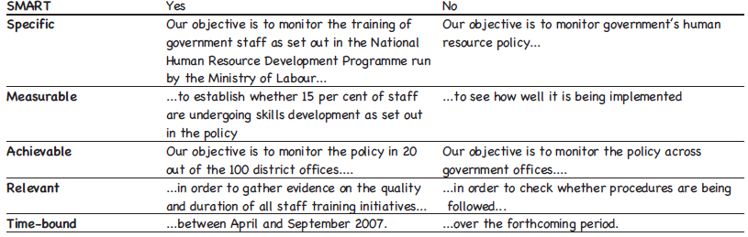

4.2. Gathering evidence
The evidence is of key importance for policy monitoring work. Because of its purpose the type of evidence gathered in monitoring work is also called evidence-based advocacy. This name quite rightly underlines the fact that the main purpose of monitoring is to generate evidence to advocate for positive change.

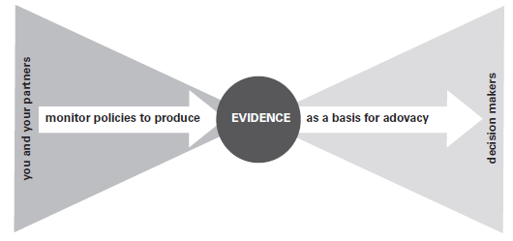

There are two main ways of capturing information as evidence the quantitative and qualitative evidence.
Quantitative evidence is captured in the form of numbers. For example, quantitative evidence about the implementation of an HIV and AIDS policy could include data on prevalence rates, infection rates and numbers of people receiving treatment. Quantitative evidence aims to be objective, verifiable and measurable.

Qualitative evidence is expressed in the form of words or images. It generally aims to explore or convey ideas, opinions, perspectives, experiences, feelings and insights. For instance, qualitative evidence about the implementation of an HIV and AIDS policy could include personal accounts of the obstacles to treatment or records from a group discussion with young people on sexual behavior.

Ideally, both quantitative and qualitative evidence could be used in monitoring policies. If gathered correctly, quantitative evidence will allow you to draw more general conclusions. Qualitative evidence, on the other hand, usually adds depth and meaning to your work.

The ideal situation is to use a combination of methods to gather both types of evidence and then compare the findings from each. This practice is usually called ‘triangulation’.

It is useful to combine evidence from different sources to construct a powerful advocacy message. Sources of information are usually divided into two main categories:

Primary sources give you original, first-hand information that has not been analyzed or interpreted. For example, primary sources of information about child labor could include raw data on numbers of children or types of labor, or first-hand accounts from children or adults recording their experiences or opinions.
Secondary sources provide information that has been edited, analyzed, or otherwise commented on. For example, secondary sources of information on child labor could include a government report presenting and discussing statistics on child labor, or an article outlining children’s views on working in dangerous circumstances.

4.3. Ways of gathering evidence
There are different ways of gathering and analyzing evidence about a policy. Your methodology reflects the decision of how you will monitor the policies and programmes you have identified.

4.4 Interviews
Being able to ask good questions is critical to gathering evidence, whether you are working with citizens, service providers, government officials, donors or community members. In every case, the way you ask questions will determine the quality of the answers you receive.

An interview is a discussion between two or more people. The aim is to gain information or a deeper understanding about a specific issue. An interview is usually initiated and led by someone who wants information (the interviewer). The questions are answered by people whose views or knowledge are being gathered (the respondents). Interviews can be conducted in person, via telephone, internet or postal correspondence.

There are different types of interviews, they can range from formal and pre-planned to more open-ended and conversational. They are usually divided into the following broad categories:

Structured interviews
These are question-and-answer sessions that follow a carefully planned order. The interviewer has a strict list of questions to pose to each respondent in exactly the same order. The answers are strictly recorded, often using a survey questionnaire form.

They are most useful when you want to gather specific, accurate details from many individuals in a consistent way. They help you to gather evidence that can readily be coded, counted and categorized.

Unstructured interviews
These are conversations in which the interviewer guides the discussion, while allowing the respondents to ‘tell their own story’. The interviewer usually has some questions in mind beforehand, but will adjust these as the interview unfolds. In addition to this, it is important to ask the respondents to explain or expand what they have said in order to gain more understanding and insight.
They are most useful when gathering evidence on complex or sensitive topics and when you want to understand the dynamics and experiences involved.

Semi-structured interviews
Semi-structured interviews fall somewhere between the other two approaches. The interviewer is likely to have a pre-planned list of questions, but may adjust the order and emphasis to learn more.
They are ideal when you hope to gain understanding of the respondents’ different views, but also want some consistent, comparable data to tabulate. It is possibly the most time-consuming approach, because it tries to cover a pre-determined set of questions while also allowing space for further discussion.

Questions
There are a number of ways to ask a question about the same topic. Here are some options to think about when planning an interview, designing a survey or planning the agenda for group discussions:

Open questions: the respondent is allowed to answer in his or her own words. For example:

What do you think about the services being provided at this facility?
Why many children in this community are not attending school?

Closed questions: the respondent is provided with a limited range of responses to choose from. This is often called a multiple choice question. For example:

Do you think the services provided at this facility are:

a) excellent
b) good
c) bad
d) dreadful

50/50 questions: the respondent is given a statement or range of statements and is asked to decide whether s/he agrees or disagrees with each, or whether each is true or false. There are only two possible responses to each question. For example:

The services you received today were delivered in a friendly, professional manner. True or false?

Tick or round all that applies: This closed question format asks the respondent to choose more than one response from a range of possibilities. Unlike the multiple choice example above, the respondent is invited to mark all the responses that are true of his or her situation. For example:

Your child is not currently attending school because:

- the distance to school is too far
- you cannot afford the school fees
- you cannot afford transport costs
- he or she has no school uniform
- he or she is needed at home
- he or she is ill.

Ranking and scoring: Questions that use ranking and scoring are useful for learning more about the level of importance that people attach to different things. They can also reveal the relative importance of respondents about how they make choices. For example, the question above about school attendance could be posed to respondents to rank the reasons in the list from the most to least important obstacle. Respondents could also be asked to give each reason a score (say, between 1 and 50) that reflects how important it is as an obstacle. Scoring gives you slightly more information than ranking, because it asks the respondent to give a precise weighting to each factor.

Rating: Rating is similar to scoring, but instead of scoring a whole range of possible factors or responses (to find out their relative importance), through posing rating questions you ask the person to evaluate a single factor. For example:

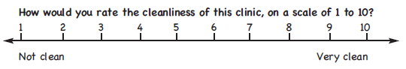
Coding answers to questions
To record evidence in a quantitative way, it needs to be counted or coded in numbers. This can be built into the design of your questions and answers (which is called pre-coding). Closed questions tend to be pre-coded. For example, in relation to a policy on security, you may ask the following question:

Pre-coding is also possible when you are using observation to gather evidence. For example, in order to track an education policy, monitors could be asked to attend a number of primary school classes. They could use the following system to encode what they observe:

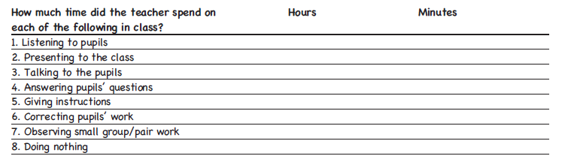

Open questions are answered in respondents’ own words. These answers can be coded afterwards (which is called post-coding). This involves assigning number values to different responses or themes so that they can be counted and compared. For example, imagine you are monitoring a policy on police conduct and you have already gathered peoples’ ideas and opinions. You could give a certain number value to every response that highlights police violence, and another value to responses that draw attention to corruption of police officials.

4.5. Surveys
Surveys are useful to gather specific information from a large number of people which can then be translated into statistical evidence. The design of the survey is vital because it determines what kind of findings will flow from it. Surveys are used by researchers to conduct public opinion, companies use them for market research and governments use them to carry out a census.

Surveys are closely linked to structured interviews. The interview is the process and the survey is the main instrument used to structure and record information. On a survey form, you usually see questions followed by spaces or blocks for recording the answers given by respondents.

Over recent years, civil society organisations have begun to use surveys to monitor government spending and policy implementation. They usually follow the below two types of surveys:

Public expenditure tracking surveys (PETS)
PETS are used to find out whether public funds have been spent in line with government policies, and if not, to establish where and why not. Monitors track the release of funds from the original allocation right through to the levels of government where they are supposed to be turned into goods and services (usually the local level). They monitor how much of the promised resources actually reach the right level (and how much seeps away), as well as the time it takes for resources to flow through the government bureaucracy. Information is collected from different sources, including those providing public services, and from local and more central government levels.

Citizen’s report cards
Citizen’s report cards are known under many names, including citizen feedback surveys, citizen scorecards and citizen satisfaction surveys. Whatever the name, the aim is usually to collect feedback from service users on the quantity and/or quality of specific government services they have received. They are also used to gather evidence on the performance of service providers and/or to compare performance across service providers.

4.6. Analyzing data and other coded information

When the collected information is coded, it means that number values have been assigned to different categories of data. For example, wherever people have chosen the same answer to a closed question in a survey, their responses are given the same number value. When evidence is expressed in the form of numbers, it makes it easier to work with large volumes of information. It also allows you to use the data in many useful ways:

- You can easily summarize and present the information in several ways. For example, even if you have 50,000 responses to a question, the fact that they are coded in numbers helps you to count up and portray your findings in a concise and straightforward way – see TOOL 3.
- You can highlight some of the features of a particular category of information. For example, you can calculate the average across a range of responses, identify which response lies in the middle (the median), or the most popular responses (the mode) – see TOOL 4.

Example: A survey on the use of public transport services

Imagine you have carried out a survey to monitor people’s use of, and satisfaction with, public transport. You conducted the survey with 20 people who regularly use public transport. (In reality, you are unlikely to run a survey with only 20 people, but for the purposes of explaining the methods below, a small sample size is more workable). There were four questions in the survey questionnaire.

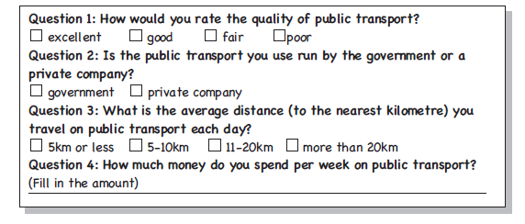
Since conducting the survey, you have used a table to record all the responses of the 20 individuals in your sample group:

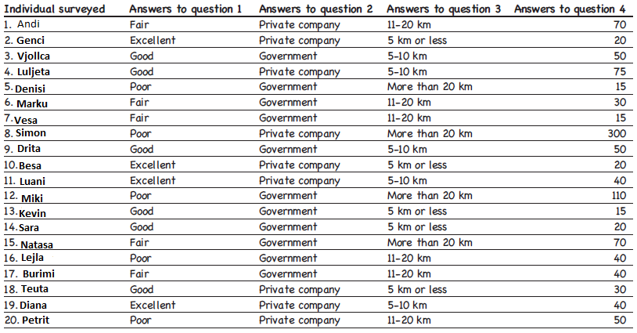
TOOL 3: Creating tables or charts to summarize data

Aim: To summarize and convey the responses and information in an accessible way.
Step 1: Ensure that the information you want to summarize has been captured in a table or spreadsheet.
Step 2: Choose one question to focus on at a time. For example, let’s take a closer look at the responses to question 1 in the example questionnaire on public transport: How would you rate the quality of public transport?
Step 3: Identify how all the people in a sample group responded to this single question. For example, by looking at the table, you can quickly calculate that out of 20 people, four rated the quality of public transport as excellent, while six thought it was good, five said it was fair and another five rated it as poor.
Step 4: Choose a format to present this finding. Three options are illustrated here: a frequency table, pie chart and bar chart.

Frequency tables
This is how the information about question 1 can be presented in a frequency table:

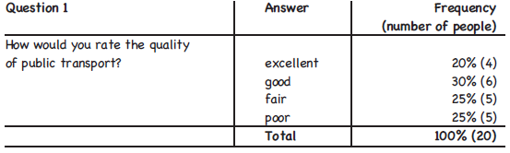

A frequency table shows the percentages of people who gave the same responses to a question, as well as the number of people that make up each share.

Charts
Many different kinds of charts can be used to display survey data and other coded information. These examples illustrate how the responses to question 1 can be summarized and presented in a visual way that is quick and easy to understand:
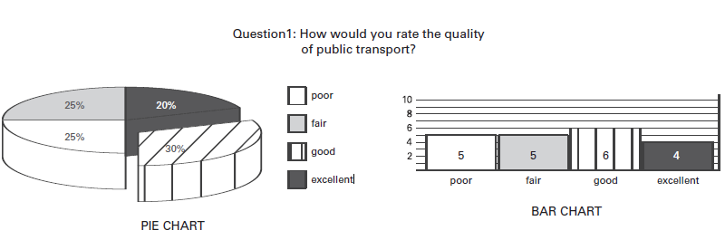

TOOL 4: Average, median and mode

Aim: To calculate the average, median and mode response to a survey question or another category of coded information. It is useful to understand all three terms and how to calculate them.

- The average is the sum of all responses divided by the number of responses.
- The median is the number that separates the higher half of a sample from the lower half.
- The mode is the most commonly observed response.

How to use this tool: To illustrate this tool, consider the responses given to question 4 of the example survey:

How much money do you spend per week on public transport?

Working out the average
Step 1: Add up the amounts given by all the respondents: the total is 1,100.
Step 2: Divide this figure by the number of responses (20): the answer is 55. So for this sample of commuters, the average amount spent per week on transport was 55.

Working out the median
Step 1: Arrange all the amounts given by respondents in order, from the lowest (15) to the highest (300). Your series of amounts will look as follows:
15 15 15 20 20 20 30 30 40 40 40 40 50 50 50 110 70 70 75 300
Step 2: Identify the amount(s) that fall right in the middle of the sequence. In this case there are two responses that lie in the middle: both have a value of 40.

Working out the mode
Step 1: Divide the responses into groups. All similar responses go into the same group.

Step 2: Observe which group contains the most responses. In this case the mode is 40.

4.6. Workshops, focus group discussions and observation

Group discussion
Discussing a programme or policy with a group is useful to understand the experiences, obstacles or issues involved. This method relies on semi-structured or unstructured interviews. The facilitator steers the discussion towards certain themes or topics but also allows the participants to take the lead in exchanging their views and introducing related issues. The term ‘workshop’ is often used to refer to any kind of group meeting where people participate to achieve a specific goal. There are two main types of workshops frequently used to gather information:

Mixed or multi-stakeholder workshops are ideal for gaining insight into the different interests and perspectives of stakeholders related a policy or programme. For example, to discuss an education policy, it could be fruitful to have a meeting with a mixed group of parents, scholars, school directors, teachers, education officials, teachers’ union representatives and administrative school staff. While separate discussions with these groups can provide valuable information, hosting them together is likely to reveal more about the dynamics, conflicts and synergies among the various role-players. These relationships and the issues underpinning them can make or break the success of policy implementation.

Focus group discussions are workshops held with participants who have a common interest. For example, they may be part of a specific social category (such as young adults), an interest group (such as environmentalists) or an occupation (such as farm workers). There is no fixed rule about the number of people to include, but a good size is often between five and 14. Focus group discussions work best when you want to gather substantial information from a specific group on a topic that is directly relevant to their lives. So, for example, to know why a given health policy is struggling to make a difference, you could facilitate a series of focus group discussion with nurses working in rural clinics.

Participation in group discussions
One of the challenges (and opportunities) posed by group discussions and workshops is being able to hear the views of those usually excluded from policy debates. These could, for example, be women, people with disabilities or refugees. So it is important to think carefully about the composition of those attending and to manage the power dynamics so that everyone can participate fully and have their say.

Seeing the whole picture
Observation is a way of gaining knowledge about a situation or community by watching it ‘as it functions’. All other methods discussed in this chapter involve asking people questions. This means they step outside their normal activities, even if only for the brief time it takes to complete a survey. When asked to reflect on their everyday experiences, people sometimes give answers or comments that they think are expected of them. Observation, on the other hand, is about watching what people do in their usual routines and practices.
For example, you could visit ten clinics and record how many people visit each clinic over a set time period, how they arrive, what they do while waiting to be helped, how they cope with the heat, who is allowed to go to the front of the queue, how long it takes on average for each person to be attended to and soon. Observation is a popular method of monitoring during elections. Observers usually visit polling stations to record what they see, taking note of anything that may be out of step with electoral policy. Observation can be combined with other methods, such as group discussions and interviews, to write a case study.

What can you learn about policy implementation through workshops and interviews?
Evidence gathered through discussion can help you understand why a policy or programme is not delivering its intended results. It can also help to shed light on how people experience policy implementation. So the information gathered from workshops and discussions often provides another layer to the process of analysis.

For example, the results from a survey may show that 78 per cent of HIV positive people are dissatisfied with the health services they receive at local clinics. Qualitative evidence from focus group discussions with HIV-positive teenagers for instance, could then help you to gain a deeper sense of what drives their dissatisfaction, how they cope with failures in the health system and how they would like to see it changing in future.

Unlike coded information, it is not so easy to set out exact methods for analyzing qualitative evidence. There is no prescribed way to interpret people’s views and stories. The best way to decide how to analyze qualitative policy information is to consider what you want to highlight for the attention of powerful stakeholders. To present a compelling case, it is often important to draw attention to:

- general patterns that keep emerging, and seem to be typical of the way a policy is being implemented or experienced;
- system problems that undermine policy progress and seem to be deeply rooted in the way a policy or programme functions in practice.

Facilitating with evidence in mind
Different group discussions require different styles of facilitation.
For example, if the aim of a workshop is to strengthen relationships between participants, the direction the conversation takes is not that important, as long as people are engaging with each other in a new way. If, on the other hand, the aim of a workshop is to gather evidence about a policy, it is important to ensure that you end up with the kind of information you need.
Here are some tips to keep in mind:
- Explain clearly what the workshop is about;
- If possible, display the workshop aim in words on a flip chart and gently steer the discussion back to this core focus whenever participants stray too far from it;
- Open questions encourage more discussion than closed ones;
- Encourage everyone to participate, politely ask dominant participants to give others a chance and create openings for quieter members to speak;
- Use probing questions to gain a better understanding of people’s experiences and opinions; the key word here is why.

TOOL 4: Analyzing information from interviews and workshops

Aim: To extract information and insights about policy implementation from the records of interviews, workshops and other discussions.

How to use this tool
Step 1: Read through the notes of what was said during the workshops or discussions;
Step 2: Ask the following ten questions to detect patterns in what people said in relation to the policy.

- Who generally has access to the benefits of this policy and who does not?
- Who is most often excluded or marginalized?
- Which government officials or service providers have the most power to make a difference?
- Who seems to benefit when this policy is not working as it should?
- What are the prime obstacles for real improvements?
- Who has responsibility for, or control over these obstacles?
- How do different stakeholders cope with weaknesses and failures in this policy or programme?
- What resources or assets are needed in order for this policy to function?
- Who has power over these resources and assets?
10. What keeps these patterns in place?

Step 3: Write a summary to explain and substantiate the patterns emerging from your analysis above.
For example, imagine you have reviewed the notes of several focus group discussions about problems with the delivery of health services. You noted that in all of these, clinic managers complained about friction they were experiencing with nursing staff. In your summary, record the trend that you noticed and then back it up with information from the workshop records.

For example: In six out of eight districts, clinic managers noted that they were experiencing conflict with nursing staff. The conflict appeared to stem from inconsistencies around the prescribed working hours for nurses. The nurses who took part in focus group discussions in Mitrovica and Vushtrri municipalities said that clinic managers did not provide them with the medical provisions needed to care for patients....etc, etc

Step 4: Don’t forget to put your evidence into context. Prepare an introduction to your summary that gives some background information on where the evidence comes from and how it was gathered.

Step 5: If appropriate, select a few quotes that give expression to people’s real perspectives and experiences of a policy. But beware of simply using quotes to ‘spruce up’ quantitative findings. Insights from workshops and discussions can be used to mark patterns and explain trends emerging from all your evidence.
For example; Child labor was discussed at length with focus groups in Albanian Serbian and Bosniak communities. Children and parents participated in separate discussions, to encourage freedom of expression. Views were gathered from 140 children in total. Looking at the responses of the children across all three communities, the following reasons were given for the continued practice of child labor...

Exploring the root causes of policy failures -evidence from workshops, discussions and observation helps to discover why a policy or programme is not working as it should.

For example, imagine that it is clear from both survey and workshop evidence that people are unhappy with a certain job creation programme. Using tool 5 below and the evidence at your disposal, can you uncover layers of causes contributing to this situation? The deeper you go, the more likely you are to identify system problems: these are the root causes that are the most difficult and essential to change. To begin knowing root causes and systemic problems, it is useful to identify:

- what factors may be working together to make the policy a success or failure?
- weaknesses in the policy or programme that may be fuelled and made worse by other factors?
- positive aspects of the policy that are undermined, minimized or cancelled out by other factors?
- bottlenecks and blocks that prevent the policy from functioning effectively?
- how and why these bottlenecks and blocks are protected and kept in place?
- the underlying interests, traditions, arrangements, behavior patterns, structures or practices that prevent the system from changing.

TOOL 5: ASKING WHY

How to use this tool
Step 1: Begin by asking the most obvious question you can think of about the outputs or outcomes of a policy. Taking the example of the job-creation programme discussed above, this question might be: Why are people unhappy with this programme?
Step 2: Use available evidence from workshops, discussions, observation, interviews or other sources to answer the questions as accurately as you can. For example, the process of asking questions about the job-creation programme could unfold as follows:

Q Why people are unhappy with the job creation programme?
A They said that they couldn’t find jobs after participating in the programme for six weeks.
Q Why couldn’t they find jobs after participating for six weeks?
A Programme didn’t provide them with the skills that are needed in the workplace.
Q But why did the programme not focus on skills that are needed in the workplace?
A Well, it was initially meant to be a six-month course, but it only ran for the first six weeks. They were going to cover other skills areas in the weeks to follow.
Q But why did the programme only run for six weeks, if it was meant to run for six months?
A district labour office ran out of funding for the programme.
Q Why did the district labour office run out of funding?
A The financial officer submitted a budget that was too small.
Q Why... etc

Step 3: Keep asking questions until you reach one that you can’t answer with available information. You will probably need to gather more evidence before you can dig any deeper. But you should have a clear idea of exactly what kind of evidence you need.

Chapter 5- Using Policy Evidence to advocate for change

This part of the toolkit aims to help you use the evidence you have gathered to bring about change. How can evidence about a policy be used to inform the direction of future policy and what is an advocacy message and how to put the message across?

5.1 Making recommendations for policy change
The reason for monitoring policies is to advocate for positive changes based on your evidence. The gathered evidence provides you with fuel for your advocacy work and it should allow you to draw conclusions about a government’s present course of action and make suggestions about what needs to change. These are the recommendations you will make to powerful stakeholders to influence the future direction of a programme or policy:

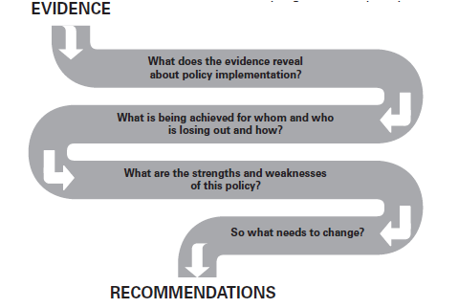

Who should generate policy recommendations?
Like many aspects of policy monitoring, formulating recommendations can be done with more or less participation. In most instances it is useful to get different stakeholders involved. This will also help you to understand the implications of your evidence from more points of view. You could, for example:
- facilitate a meeting of multiple stakeholders to discuss the evidence and decide which proposals to put forward;
- have separate focus group discussions with different stakeholder groupings and draw together the recommendations flowing from each;
- ask those involved in policy implementation to help formulate recommendations – for example, front-end service providers may offer useful insight when it comes to making practical policy suggestions;
- invite organisations or individuals with expertise in the policy area to consider the evidence and generate recommendations on specific challenges or obstacles;
- create a small but diverse team within your organisation or network to take the lead in formulating recommendations, and then review and refine these with a broader range of stakeholders.

TOOL 6: Immediate and longer term remedies

Aim: To examine evidence about a policy and formulate immediate and longer term recommendations on how to change the policy itself and/or its implementation.

How to use this tool
Step 1: Review the evidence on policy implementation. Use the information to make a comprehensive list of problems, relating to the programme or policy you are monitoring.

Step 2: Consider which of these problems may be relatively easy to address. Identify which problems are more systemic and will call for more demanding, longer-term solutions. If possible, write each problem on a separate card and arrange them along a continuum like the one below:

Step 3: In relation to each problem, consider what actions you think government could or should take to resolve the situation – or to move in the direction of finding a solution.

Step 4: Formulate these suggested actions as recommendations. You can use a table like the one below to help you differentiate between:

- immediate or first-aid remedies – steps that should be taken now to ameliorate the worst effects of a policy or programme
- longer - term remedies – the systemic changes that are required to address the root causes of poor or inadequate policy outcomes.

Attach time-frames to the longer-term remedies. This will indicate when you think the actions should have been taken.

Step 5: Make sure all your recommendations are clear, reasonable, and viable and affordable.

Example: Recommendations relating to a feeding programme in a school?

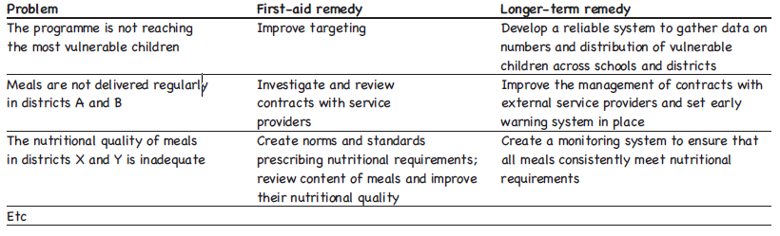

5.1 Planning for advocacy

CSOs, interest groups, activists and even policy-makers themselves advocate to call for the creation of new policies or to reform existing ones, to make policy implementation more effective or to see that policies are enforced as planned. Once you have gathered and analyzed evidence about a policy and formulated recommendations, the next step is to present these findings to powerful stakeholders. Here are some different roles that can be adopted during advocacy.

Examples of advocacy strategies

- Pressuring decision makers to change policies, laws, programmes or budget allocations;
- Mobilizing people to demand changes in policies and resource allocations;
- Raising awareness and reporting abuses of power and violations of human rights;
- Establishing and monitoring standards, rules and procedures and creating systems of incentives and sanctions to enforce them;
- Tracking the quality of government services;
- Educating the public and decision-makers about human rights and policy issues;
- Using the legal system to claim entitlements and to achieve justice and equality.

The roles of an advocate

The word advocacy comes from the Latin ad vocare, which means to speak for someone. The chart below illustrates some of the different meanings attached to this role:

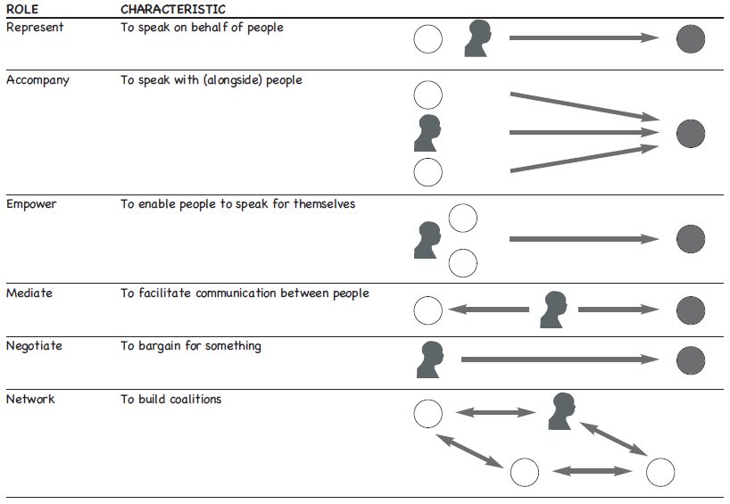

Different forms of engagement

Chapter 3 provides ideas for identifying the target audiences of your advocacy work. These may include stakeholders you want to:
- inform with your evidence and mobilize to support your advocacy message;
- Influence with your evidence and recommendations, so they initiate policy changes.

There are many ways to engage and communicate with those you have identified as the target audience(s) of your policy monitoring work. Here are just a few examples:

- Private meetings with powerful stakeholders can sometimes allow for more substantial interaction than would be possible in public settings;
- Public meetings are useful means to encourage broad debate and discussion;
- Requesting an audience with members of parliament gives you an opportunity to present what you have learnt about policy implementation;
- Seminars, workshops and conferences can be used to share information with other stakeholders and discuss your findings and recommendations;
- Marches, petitions and other forms of peaceful protest can be an effective way to add pressure to your message and raise your media profile;
- Media briefings and the preparation of media kits are valuable means to engage the interest of journalists and editors and encourage them to report on your findings;
- Public awareness campaigns can play an essential role in informing people about the evidence you have gathered and mobilizing action to call for change.

How to put your message across
It is essential to consider when is the best moment and chances to influence decision-makers with the gathered and analyzed evidence.

For example, if you want to influence budget allocations to a specific programme, you will need to get your message across at a particular time in the budget process. You will also need to decide in what format(s) you will communicate your evidence and recommendations. You might decide to produce presentation slides, hand-outs, pamphlets, brochures, easy-to-read guides, comics, newspaper or magazine articles, books, formal submissions and/or reports. Some materials take longer to prepare than others, and this should be factored into your planning.

Preparing your position for delivery for different audiences
All these activities require different outputs, different messages and different competencies. In direct and personal contact with policy makers and political decision makers, you have to improve your personal negotiation skills, and reflect on the attitude of yourself, of your political target, and deal with that in your conversation.

In contact with the media, you need either writing, presenting skills or media training.

When campaigning and mobilising masses you have to be an excellent speaker and leader, not everyone can do everything well – so divide roles according to positions and competencies amongst the members of alliances or organisations you work with.

- For lobbying: you can prepare a position paper, a political statement, organise an expert meeting, have a personal meeting with a policy maker or minister;
- For communication: you can address the media with statements, write an article, provide updates on Twitter or Facebook, or give an interview;
- For campaigning: you can organise a petition or hold a demonstration.

Tips for designing effective messages

- Know your audience;
- Know your political environment and moment;
- Keep your message simple and brief;
- Use everyday words and images;
- Use real-life, human stories;
- Emphasize positive values: what are you calling for;
- Use clear facts and numbers creatively: avoid over-using statistics and jargon;
- Use precise, powerful language and active verbs;
- Deliver a consistent message through a variety of channels over an extended period of time; Repetition is vital: deliver the same message in different ways;
- Deliver your message through a source your audience finds credible. The messenger may be as important as the message itself;
- Present the message in a way the audience will understand. The issue needs to be specifically aimed at the target group. This does not require any compromise on core values;
- You may need to simplify the message to reach a broad public audience. At the same time, your message should be substantial enough to convince decision-makers;
- Anticipate your target audiences likely objections and how to counter them;
- Produce a checklist of their likely arguments and your answers;
- Present a solution and encourage your audience to take action to achieve it;
- Practice presenting the message to other people to make sure they understand it;

Useful resources

- Advocacy and Policy Influencing for Social Change, TACSO manual, (2011).
- What is Monitoring, Human Rights Information and Documentation Systems, International HURIDOCS, 2010;
- Monitoring government policies, a toolkit for NGOs, CAFOD, Christian Aid and Trócaire (2012)
- Advocacy for social justice: a global action and reflection guide, by David Cohen and Rosa de la Vega (2002). Oxford: OXFAM/Advocacy Institute.
- Advocacy toolkit: Understanding advocacy and Practical action in advocacy, by Graham Gordon (2002). Teddington: Tearfund. ISBN 1 904364 00 4.
- A new weave of power, people and politics: Action guide for advocacy and citizen participation, by Lisa VeneKlasen & Valerie Miller (2002). Oklahoma: World Neighbors. ISBN 0 942716 17 5.
- Civil Society Organization Management, TACSO manual (2011).
- How civil society organisations use evidence to influence policy processes: A literature review, by Amy Pollard and Julius Court (2005). London: Overseas Development Institute (ODI).
- Influencing poverty reduction strategies: A guide (2002). Oxford: OXFAM. Introduction to applied budget analysis compiled by Len Verwey and Marritt Claassens (2005).
- Improving Local Governance and Service Delivery: Citizen Report Card Learning Toolkit: www.citizenreportcard.com/index.html
- Monitoring government budgets to advance child rights: A guide for NGOs, compiled by Judith Streak (2003).
- Tools for policy impact: A handbook for researchers, by Daniel Start and Ingie Hovland (2004).

Civil Society Organisation Management, TACSO manual (2011).
See annex 1- list of useful resources
Monitoring government policies, a toolkit for NGOs, CAFOD, Christian Aid and Trócaire (2012).
ibid
Christian Relief and Development Association Training Centre, Materials for Training Programme on Advocacy and Policy Influencing, CRDA

